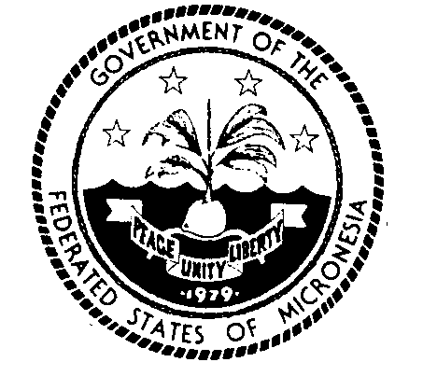
Permanent Mission of the Federated States of Micronesia to the UN
300 East 42 Street, Suite 1600 Telephone: (212) 697-8370
New York, N.Y. 10017 Facsimile: (212) 697-8295
e-mail: fsmun@fsmgov.org http://www.fsmgov.org/
_________________________________________________________________

General Assembly – Eleventh Emergency Special Session
Statement by the Micronesian delegation

New York, 22 February 2023 Check against delivery

Mr. President,

I align this statement with the statement delivered by the distinguished representative of Fiji on behalf of the Pacific Islands Forum (PIF) members. In my national capacity, I would like to add the following.

It has been a year since the Eleventh Emergency Special Session of the General Assembly adopted a resolution on the Aggression Against Ukraine. Since then, the war has only intensified with disturbing human rights violations waged against the people of Ukraine by Russia. The ongoing unjust war has displaced millions of people with insurmountable death and destruction. It is disconcerting to see Russia’s utter disregard for the call from the International Community for a cessation of their hostilities toward the people of Ukraine and to withdraw all of its military forces from the territory of Ukraine within its internationally recognized borders.

We, once again, express our appreciation to its neighbors who continue to provide food, shelter and safety for the most vulnerable.

Today’s draft tries to look towards the future. It underscores the need to reach a comprehensive, just and lasting peace in Ukraine in line with the principles of the Charter of the United Nations. It reaffirms the commitment to the sovereignty, independence, unity and territorial integrity of Ukraine within its internationally recognized borders, extending to its territorial waters. And it recalls the obligations under international humanitarian law.

Micronesia supports the draft and is one of its sponsors.

I thank you!

