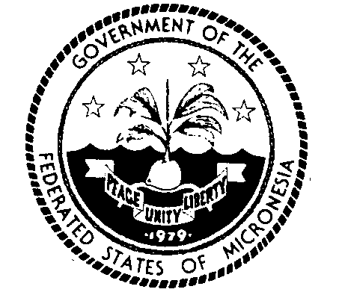
Permanent Mission of the Federated States of Micronesia to the UN
300 East 42 Street, Suite 1600 Telephone: (212) 697-8370
New York, N.Y. 10017 Facsimile: (212) 697-8295
e-mail: fsmun@fsmgov.org http://www.fsmgov.org/
_________________________________________________________________

Security Council Open debate on “Sea-level rise: implications for international peace and security”

Statement by the Jeem S. Lippwe
Permanent Representative

New York, 14 February 2023 Check against delivery

Mr. President,

At the outset, my delegation associates with the statements delivered today by Samoa on behalf of the Alliance of Small Island States, Tonga on behalf of the Pacific Islands Forum, Palau on behalf of the Pacific SIDS, and Nauru on behalf of the Group of Friends on Climate and Security. My delegation also congratulates Malta on assuming the Presidency of the Security Council and organizing the open debate today.

Mr. President,

As stated in the Charter of the United Nations, the Security Council has the primary responsibility on behalf of the Members of the General Assembly for the maintenance of international peace and security. This discharge of responsibility must, among other things, be in accordance with the Principles and Purposes of the United Nations. Two of those Purposes are the development of friendly relations among nations based on respect for the principle of equal rights and self-determination of peoples; and the achievement of international cooperation in solving international problems of an economic, social, cultural, or humanitarian character.

In that regard, climate change-related sea-level rise presents a challenge that the Security Council must be seized of. As others have noted today, such sea-level rise poses a particularly acute threat to the overall peace and security of small island developing States like my own, given our relatively small land masses, populations, and economies, our geographical remoteness, and our deep cultural ties to and reliance on our island homes. Distressingly, and on a related note, there is a school of thought in international law and discourse that once sea-level rise inundates the land territory of a State, then that State automatically ceases to exist and no longer enjoys Statehood among the international community.

In my delegation’s view, that school of thought must be rejected by the Security Council, and we call on the Security Council to do so. It is deeply disruptive to the peace and security of a people – and violative of the Principles and Purposes of the United Nations that I identified earlier – if the status of these people as a State is deemed by the international community to be extinguished by a phenomenon for which such people have minimal responsibility, if any. Such people will not have engaged in any act of self-determination that endorses that extinguishing, and forcing such people to go along with the loss of Statehood is fundamentally contrary to the development of friendly relations among nations. Additionally, to the extent that the forced extinguishing of their Statehood disrupts that people’s access to economic, humanitarian, and other types of benefits, including rights and entitlements flowing from maritime zones, it is fundamentally contrary to the achievement of international cooperation in addressing economic, humanitarian, and other international problems. In light of the foregoing, the Security Council must make clear, in accordance with the duties of the Security Council and the Principles and Purposes of the United Nations, that the loss of land territory due to climate change-related sea-level rise does not automatically translate to a loss of Statehood enjoyed by the people of that territory.

To conclude, my delegation echoes the call by others for the appointment of a Special Representative for Climate and Security. Such a Special Representative can, among other things, strengthen the ability of the United Nations to understand and respond sensitively to all facets of the challenge of climate change-related sea-level rise, including the implications of such sea-level rise for Statehood and other matters of international law. In a similar vein, we support the initiative started by Vanuatu for the General Assembly to request an advisory opinion from the International Court of Justice on climate change. A Special Representative for Climate and Security can play an important role in facilitating the full engagement of the United Nations system and its Members in that initiative once the General Assembly adopts the resolution submitting the request to the International Court of Justice.

Thank you, Mr. President.

