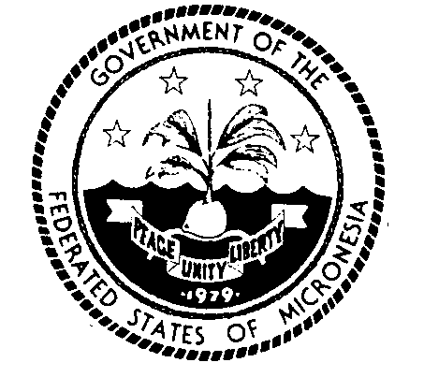
Permanent Mission of the Federated States of Micronesia to the UN
300 East 42 Street, Suite 1600 Telephone: (212) 697-8370
New York, N.Y. 10017 Facsimile: (212) 697-8295
e-mail: fsmun@fsmgov.org http://www.fsmgov.org/
_________________________________________________________________

Economic and Social Council
Commission on the Status of Women, 67th Session

Statement by the Marcus Samo
Secretary of Health and Social Services

New York, 8 March 2023 Check against delivery

Madame Chair,
Excellencies and distinguished delegates,

I align this statement with the statement delivered by the distinguished representative of Fiji on behalf of the Pacific Islands Forum (PIF) members represented in New York. In my national capacity, I would like to add the following:

This 67th session of the commission on the status of women is an opportunity to:
- accelerate efforts to address the gendered digital divide;
- increase equitable and appropriate innovation and promote access of women and girls to technology that increases their safety; and
- connects them to education and economic opportunities.

The COVID-19 pandemic not only had a set-back on our ability to deliver essential services, but further impacted our ability to meet our goals in these important areas. For example, while Internet is now a normal part of every household, women and their children in many parts of our island society continue to be left behind in fully enjoying the benefits of the digital innovation and essential service.

We must continue to find innovative ways to use technology as a means to advance better health outcome and improvement in the life of our people, especially the women who and children from small island countries, dispersed over thousands of miles with limited or no access to the internet.

The opportunities associated with the rapidly changing technological environment must be harnessed in a way that is friendly and sensitive to women and girls and their special needs. In Micronesia and other small island states, the cost of access to technology is often prohibitive. This presents a challenge for equitable access, as women and girls are disproportionately impacted by high costs, with those in outer islands most affected. This is a challenge that we cannot overcome alone and requires the private sector to step up and reduce wholesale costs to increase access to innovative technology.

In our small island setting, the proportion of women using the Internet to supplement their meager income is growing. This is e-commerce in practice, although on a small scale. We believe that reducing cost to Internet will increase access services and income generation opportunities.

Madam Chair,

The Federated States of Micronesia continues to make progress in making space and developing systems, services and policies that enable women and girls to be connected and to reach their full potential. The government of Micronesia has made significant investments to increase access to innovative technology for its citizens. This includes subsidies to address high energy costs targeting female headed households and work to rollout terrestrial fiber infrastructure, connect outer islands to basic broadband services, establish the critical foundations for digital government services, and strengthen the legal and regulatory enabling environment for the digital economy to thrive in FSM. In the area of healthcare for women, we have established systems for tele-health consultations that have enabled great access to diagnostic services and healthcare, particularly women. These efforts are testaments of our commitment to gender equality to ensure women and girls are not left behind. We also have a number of government-funded scholarships that support women and girls to access careers in non-traditional fields, including ICT. Digital technologies have a huge potential to improve outcomes for women and girls, yet they also pose new risks with women being left behind and exposed to new forms of violence and exploitation.

The COVID-19 pandemic led to an increase in already devastatingly high rates of violence against women and girls. This violence is also increasingly extended to online spaces. There is a need to create and sustain more online safe spaces for women, and in particular for adolescent girls. This should mean greater safety in shared spaces such as social media and also dedicated safe spaces for women and girls- that support prevention of gender-based violence. There is a need for increased cooperation to overcome the complexity of technology that adversely facilitated GBV that occurs across our borders. This includes intimate partner violence that is facilitated through technological means. While regulation of online spaces and technology is important, we must not lose sight of the fact that online violence is often an extension of offline violence and we are committed to continuing our efforts to address the underlying drivers of violence against women and girls, to stop violence before it starts.

Conversely, the use of technology and online spaces is critical in being able to provide services for survivors of gender-based violence in Micronesia with our small population spread across vast expanses of ocean. Technology has great potential for increasing access and appropriateness of services, for example increased access and suitability of information on support services, the use of telephone or video counselling services to reach survivors in remote and isolated locations and the facilitation of access to justice by electronic access to court systems or safety orders. As an example of this, we recently held online training on gender and GBV for our court staff and we also opened our first telephone counselling services in the state of Chuuk during COVID-19.

Finally, we are concerned that the cost of digital connection is the degradation of the natural environment. We are aware of the unavoidable obsolescence and the design of digital devices which can lead to increased levels of extraction and processing of rare minerals and other raw materials that only add to the worsening impacts on our environment and climate change. The impacts of which are felt so acutely by the women and girls of Micronesia. Micronesia is on the frontlines of climate change, and we cannot sacrifice our safety and our survival as we strive toward a more equitably connected and safe online world.

I thank you Chair.

