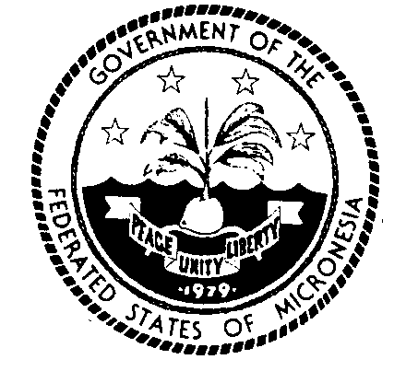
Permanent Mission of the Federated States of Micronesia to the UN
300 East 42 Street, Suite 1600 Telephone: (212) 697-8370
New York, N.Y. 10017 Facsimile: (212) 697-8295
e-mail: fsmun@fsmgov.org http://www.fsmgov.org/
_________________________________________________________________

Informal meeting of the plenary on the intergovernmental negotiations on the question of equitable representation on and increase in the membership of the Security Council and other matters related to the Council

Statement by H.E. Jeem Lippwe
Permanent Representative

New York, 3 April 2023 Check against delivery

Co-Chairs,
I join my distinguished colleagues in thanking you for convening this meeting. Micronesia aligns itself with the statement delivered by Her Excellency Ambassador Rhonda King of St. Kitts and Nevis, on behalf of the L69 Group. Please allow me to make some comments in my national capacity.
Co-Chairs,

At the current intergovernmental negotiations (IGN), we are asked to weigh in on the Cluster of Categories of Membership. The L.69 group has placed our Group’s common views on the table including on the Framework document. Our proposal calls for expansion in both categories of membership in the Council, and broader participation by everyone, including a non-permanent seat for Small Island Developing States (SIDS), which membership would allow their contributions from their own unique security challenges and perspectives on the existential threats facing the SIDS. If anything, an expansion in both membership categories is not only inclusive but makes the Council representative, effective and accountable.

It would be unrealistic to ignore the inevitability that the United Nations Security Council needs to be reformed to correct an outdated structure. It should not leave the African Group and the developing world marginalized. In our views, these factors if taken into account in the Council’s reform process would lead to renewed confidence in the Charter.

Co-Chairs,

I am fully aware of what we have been asked to do at this meeting but the only way we can find true convergence, compromise and progress towards a feasible reform is through political discussions and negotiations facilitated by a process in which there is a text containing all positions and proposals and is member-state driven. For years, countless statements by UN members, countless hours we have spent, yet all the planning and all the meetings have made little difference. The status quo is no longer an option and is deemed unacceptable. We are all aware of the very heavy schedule of major conferences and other meetings that are taking place at the United Nations and elsewhere. These meetings are necessary for the advancement of the UN’s agenda, and it’s equally important that small island developing states, like mine, participate actively and with continuity.

Finally, the webcasting and record keeping of our meetings are small steps in the right direction and very much appreciated by this delegation.

I thank you Co-Chairs.

