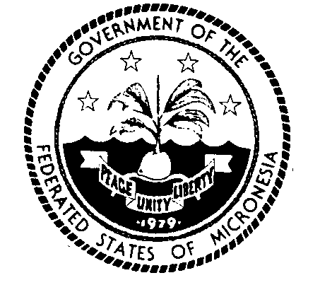
Permanent Mission of the Federated States of Micronesia to the UN
300 East 42 Street, Suite 1600 Telephone: (212) 697-8370
New York, N.Y. 10017 Facsimile: (212) 697-8295
e-mail: fsmun@fsmgov.org http://www.fsmgov.org/
_________________________________________________________________

78th Session of the United Nations General Assembly
Agenda item 71(b): Statement before adoption on “Human rights questions, including alternative approaches for improving the effective enjoyment of human rights and fundamental freedoms”

Statement by: Delegation of Micronesia

New York, 10 November 2023

Thank you, Chairperson.

Micronesia is glad to co-sponsor this resolution and is grateful to the United States for presenting this biennial resolution on “Strengthening the role of the UN in promoting free and fair elections and democratization” in this Committee. The resolution aims to promote the universal values of democracy, based on the free will of the people, and their full participation in all aspects of public affairs. It also emphasizes the need for free and fair elections for all citizens.

Micronesia’s Constitution guarantees the protection of the rights of all its citizens, including women, children, and persons with disabilities. Moreover, there is a need to promote the rights of marginalized and underrepresented groups, such as women, girls, and persons with disabilities, in political participation and voting. The resolution seeks to reaffirm this commitment.

The new topic that is addressed this year, which involves minor additions to the 2021 resolution, is about the connection between freedom of expression and media freedom during all stages of elections. We wholeheartedly support these additions and are honored to be co-sponsors of the resolution.
I am pleased to note that the previously agreed-upon language has been retained in the text, which includes important paragraphs on marginalized groups. Individuals belonging to such groups are often deprived of their right to free and fair elections and fall prey to discriminatory acts carried out with impunity by those in power. Therefore, I strongly support OP7, which is a crucial paragraph that emphasizes this important issue.
Micronesia strongly believes that every voter has the right to participate in free and fair elections without any discrimination based on their background or identity. If the General Assembly decides not to take into account the marginalization or vulnerable situation of any group mentioned in the text, it would send a dangerous message to all vulnerable groups. We are disappointed that certain amendments were tabled as an attempt to weaken this language, but we are relieved that they were not adopted.

Thank you!

